Designated Historic Landmark – A Kiss of Death

I had the occasion recently to visit family and friends in Western Pennsylvania. A brief pre-Christmas chance for reacquaintance and holiday cheer. Since there are so many houses to visit, each spread relative far from the others, there is always some wrestling with logistics, especially where to stay. After some deliberation, we decided to stay near the point – the narrow portion of Pittsburgh that lies at the place where the Allegheny River, coming from the north-east, joins the Monongahela River coming from the south-east, to form the Ohio River.

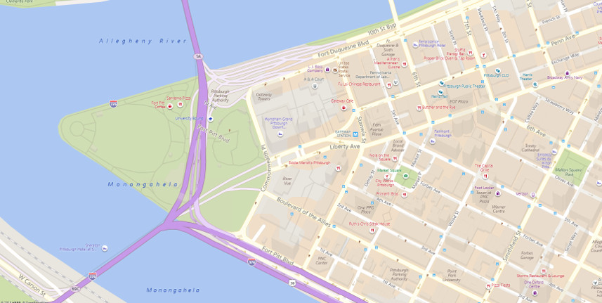

The location is beautiful and, because of a very late booking, also economical as the hotel needed to sell rooms, even at the rather absurdly low rate that I received. But this post isn’t about the law of supply and demand as it applies to the hotel business. No, it is about the moribund state of what was once one of the most vibrant locations in Pittsburgh and why.

Nearly three decades ago, while attending one of the fine institutions of higher education in Pittsburgh, I used to amuse myself by heading into the shopping districts. A particular favorite was Kaufmann’s department store located on 5th avenue consuming the entire block between William Penn Place and Smithfield Street.

Known for its iconic clock, its window displays, and its gourmet deli on the 9th floor (note the plaque below the ornate support of the clock - it and others like it play an important role in what follows),

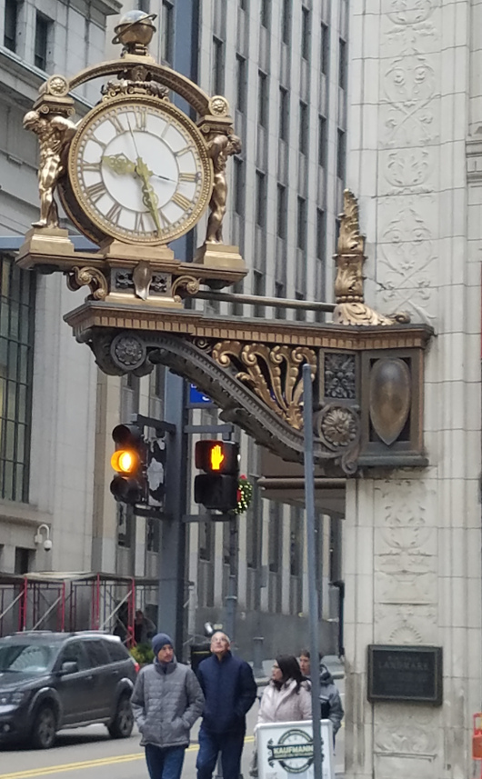

Kaufmann’s anchored one end of what was an exciting set of stores that dotted 5th avenue and surrounding streets. Towards the other end, closer to the point, were the two other large department stores of Gimbal’s and Horne’s. The Warner Theater sat in roughly in the middle, next to an old Woolworth’s ‘five and dime’ that had one of the most eclectic selection of goods and a fish market to boot. No matter the weather or, seemingly, the time of day there was always something exciting going on and a bustle of activity that one expects from a thriving metropolis. Activity on the sides of the rivers, particularly the South Side of the Monongahela, was far more sedate. The center of the city was the place to be.

As the decades wore on, the center lost it shine. One by one, the great department stores went insolvent and disappeared. The smaller shops became more run down with empty store fronts capturing greater and greater amounts of real estate. The vibrancy was gone.

No doubt, the casual observer chalks all this up to the gradual dwindling away of the industries that once made Pittsburgh one of the great cities of the world. And there is some truth to that. But only some. The bulk of the industrial upheaval actually occurred nearly forty years ago when US Steel closed down most of their activities. Pittsburgh not only survived but managed to bounce back. This resiliency was initially powered by its world class medical service and research and the numerous universities its sports. These later institutions have contributed to a growth of late in data analytics and computer technology and the Steel Town has seen a resurgence in the last ten years.

Numerous new trendy locations have sprouted up designed with idea of separating the consumer from his money in various different ways. From the thriving North Hills, to the Waterfront center that stands where the great mills once did, to the new and burgeoning hipster locales of the South Side and Lawrenceville, to the old faithful neighborhoods of Squirrel Hill and Shadyside, certain regions are active and growing.

So how to reconcile all this growth with a dead and empty downtown? In one phrase – designated historic landmarks. Almost everywhere one goes within the core of the downtown region, one finds a building bearing the historical landmark plaque (the total list of [Designated City Landmarks and Historic Districts](http://apps.pittsburghpa.gov/redtail/images/4214_Locally_Designated_Properties_November_2018.pdf) spans 14 pages). And this plaque is the economic kiss of death.

To understand just why a designation as a historical landmark stifles the microeconomy associated with the object in question consider the restrictions that burden the property owner. A brief consultation with [Section 1101.05 of the Pittsburgh Municipal Code](https://library.municode.com/pa/pittsburgh/codes/code_of_ordinances?nodeId=PIZOCO_TITELEVENHIPR_CH1101HISTDISIOB#TOPTITLE) shows that a property bearing the historic landmark designation cannot have exterior alterations without approval of the Historic Review Commission, an extra layer of bureaucracy over and above the mandatory Bureau of Building Inspection.

The hidden cost of ownership of such a building is far larger than is simply totaled from property taxes and upkeep and utility costs. There are opportunity costs that have to be figured as well. For example, as a younger more fitness conscious workforce begins to call Pittsburgh home, the candy shops of yore should now be replaced by yoga studios and organic markets. Simply exterior redesign, including modern signage and architectural sensibilities, should be one of the first orders of business. But these changes may be extremely costly, if not impossible, if the building in question is a historic landmark.

Each piece of land is a scarce resource unto itself. As market forces clamor for changes, historic landmark designations and the bureaucracy that goes along with them slap the invisible hand from reshaping the building to fit the demanded change. As a result, business move to locations less encumbered and the landmark falls into disuse.

Pittsburgh is by no means alone in this predicament. As the following video shows, the historic landmark designation may be spelling the end to one of New York’s most iconic bookstores.

<iframe width="560" height="315" src="https://www.youtube.com/embed/kZoIlz2y4Cw" frameborder="0" allow="accelerometer; autoplay; encrypted-media; gyroscope; picture-in-picture" allowfullscreen></iframe>

It is hard to fathom that the entrepreneurs of decades-gone-by would actually approve of these policies. After all, they were the innovators who turned their backs on older style construction and whose dynamism produced what were new structures at the time. They were willing to bury the past in favor of economic growth. Surely, they would expect no less from us today.